**SharePoint** Development Training

******************************

**-:Fourth Week :-**

**-:Day 1st :-**

**Security – User Group and Permissions:**

Some sites in an enterprise contain content that should not be available to all users. For example, proprietary technical information should be accessible only on a need-to-know basis. An intranet portal of company should be available to employees only, whereas the home page of an Internet Web site is accessible by anonymous clients.

By permissions control access to sites and site content we can manage permissions by using SharePoint groups, which control membership. Permissions also help to secure content at the item and document level.

In SharePoint we can give permission by default permission levels of SharePoint or we can create our own Permission and specify the accessibility.

**SharePoint default permissions:**

From SharePoint site home page clicking on the gear icon, we get an interface having 🡪 site permission

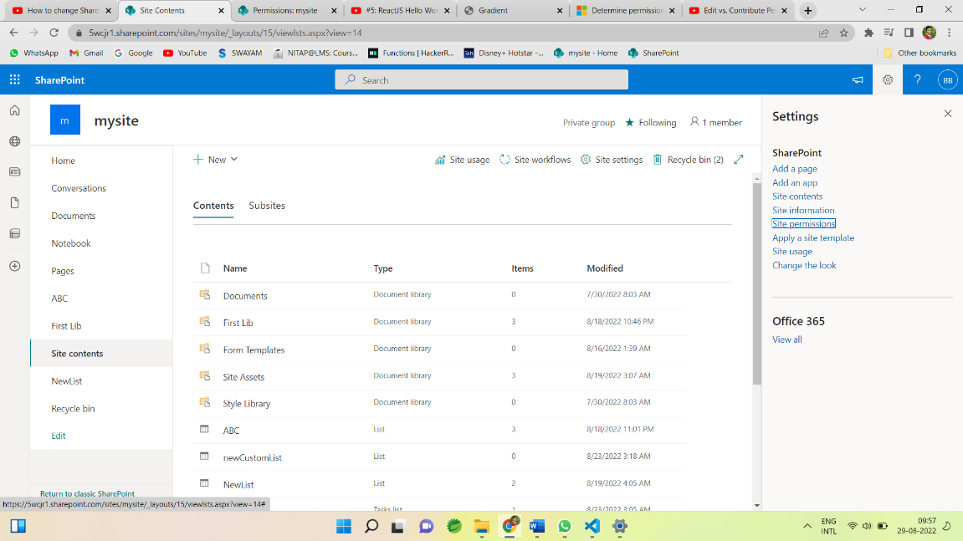

Clicking on Site permissions we get another tab of Permissions having Advance Permission setting

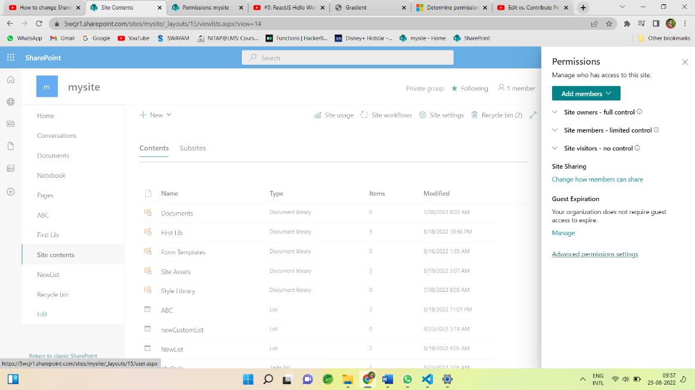

Click on Advance Permission setting we get all the Permissions Settings.

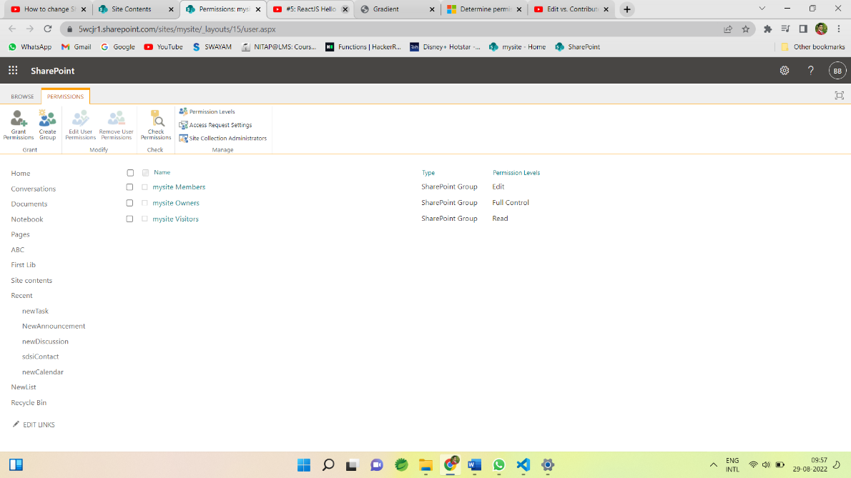

Here We can Create groups, Grant permissions, Edit user permissions, Remove user permissions, Check permissions, we can see permissions levels etc.

**Grant permissions :**

To grant permission click on Grant Permission tab and invite the person or group to give permission

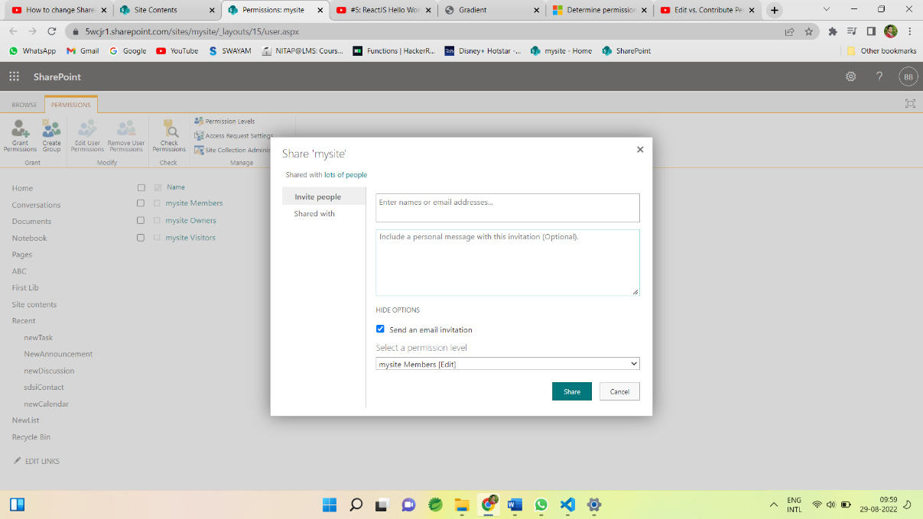

Then this user is visible in the PERMISSIONS tab with specified permission level.

**Permissions levels :**

We can see the permissions levels on SharePoint through permission levels

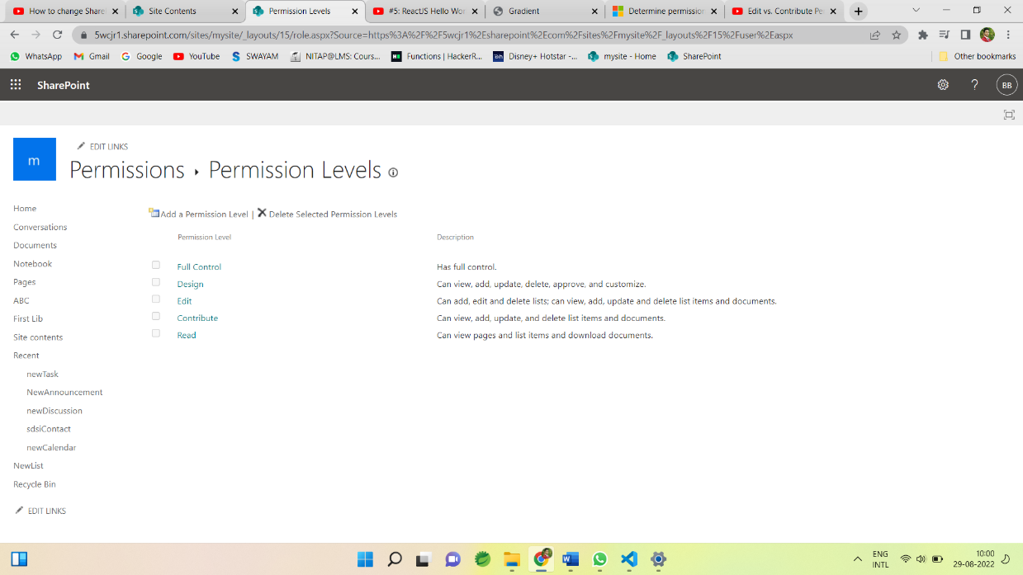

Different permissions levels are:

* Full control: Grant full control to the users or groups.
* Design: Groups having permissions of design can view, add, update, delete, approve and customise.
* Edit: Groups having permissions of Edit can add, edit and delete lists; can view, add, update and delete list items and documents.
* Contribute: Groups having permissions of Contribute can view, add, update, and delete list items and documents, But can’t add, edit and delete lists;
* Read : Groups having permissions of Read can view pages and list items and download documents.

**Default Group with permissions :**

* Visitors 🡪Read
* Member 🡪Edit
* Owner 🡪 Full control
* Viewer 🡪view

**Create Group:**

We can create group to specify the permission to that group.

Provide the name to the groups 🡪

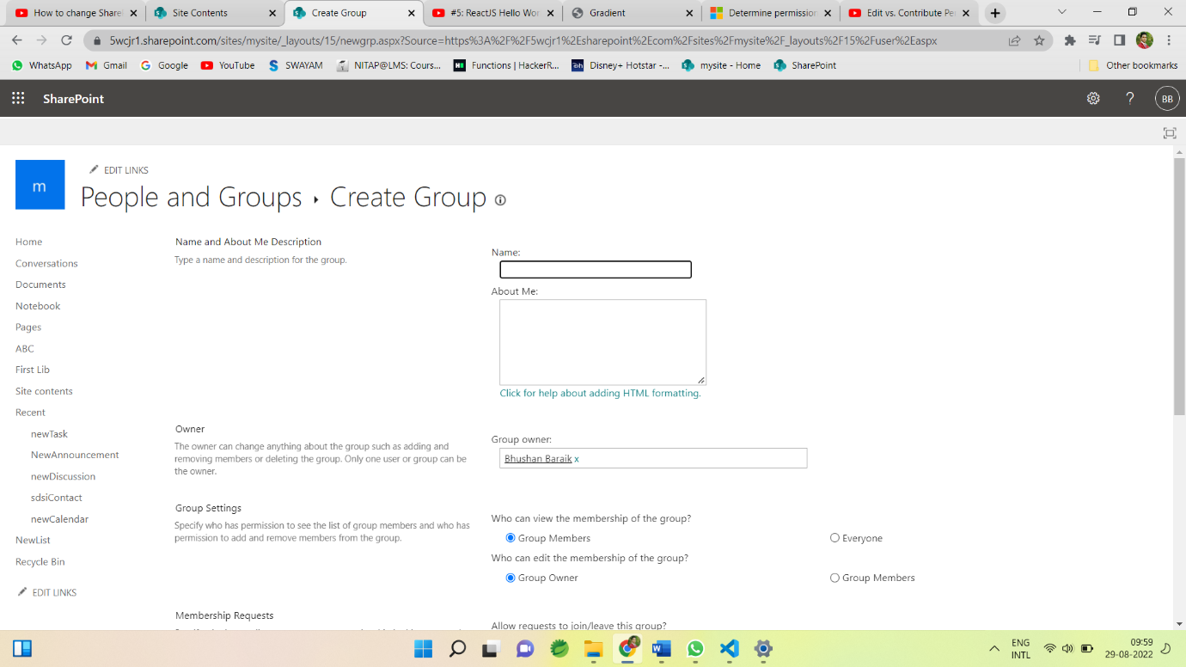

And specify the permission level for group 🡪

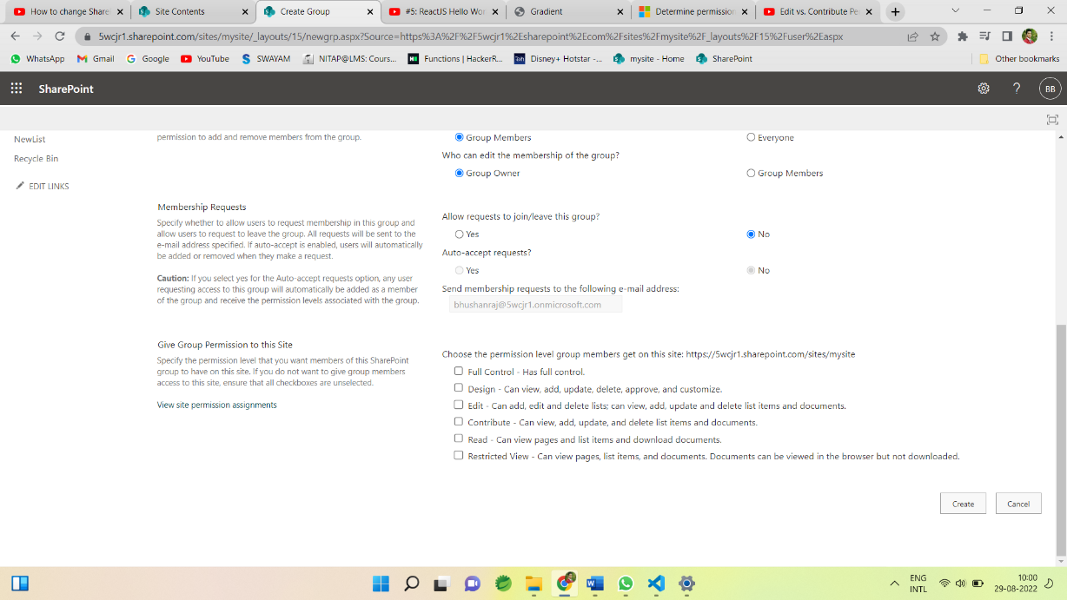

Security – User Group and Permissions is the most important part of SharePoint as SharePoint is a content sharing and management tool so its important to give the correct permissions to the different groups and users for the security of data/content.